Wenzao Ursuline University of Languages
Regulations of Dormitory
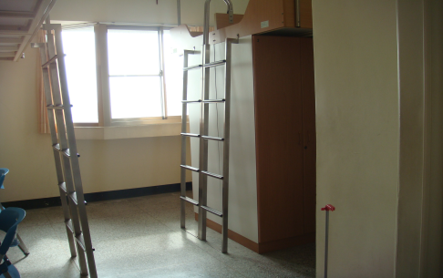
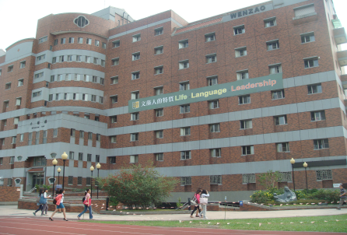
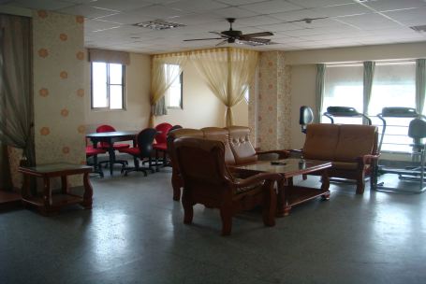

1. The fee of the accommodation for one semester is NT$12,000 and you have to pay NT$5,000 for performance bond (after the end of the semester, we will give NT$5,000 back to you).
一學期住宿費用為12,000元，另繳5,000元保證金(住宿期滿保證金退回)。
2. Curfew hours are from 23:00 to 06:30. Only entering is allowed after 22:30.
門禁時間：23:00 ~ 06:30，23:00前必須返校，早上06:30開門。
如果超過22:30，B1大門只能進來不能出去。
3. If you want to stay overnight outside the dormitory hand in the form to the office before
22: 00.
如果要外宿，請於22:00外出前完成紙本請假交至辦公室。
4. Room check randomly and evaluation will be performed from Monday through Thursday.
週一到週四抽檢寢室內外務並評分。
5. At the end of every semester, the room cleaning must be thoroughly conducted before moving out. NT$500 will be deducted as the charge of cleaning in case that the cleaning result does NOT meet the inspector’s requirements.
請於學期結束離開前，完成宿舍之清潔工作。打掃不合格者將從保證金中提撥五百元，作為清潔管理費用。
6. Without teacher’s consent, changing room or bed allocated is not allowed.
住宿床位經分配後未經管理單位同意不得變更位置。
7. The internet connection will be shut down on 1:00am and resumed on 5:00am. If the next day is holiday , there is no time limit.
宿舍網路於01:00am關閉，當日05:00am開放連線使用。若隔天為假日，則不限制使用時間。
8. The deposit shall not be returned to those who move out for personal reason during the semester.
因個人因素中途退宿者，一律不歸還保證金。
9. Smoking, alcohol, gambling and lighters are strictly banned on campus and dormitory.
校園及宿舍嚴禁抽菸、喝酒、賭博及打火機。

學生簽名(Signature):

A2.

Wenzao Ursuline University of Languages
On-Campus Dormitory
Accommodation Agreement

I, (full name), am a student of (home institute) participating in Wenzao Ursuline University Student Exchange Program from (dd/mm/yyyy) to (dd/mm/yyyy).
I hereby assert that I have read the On-Campus Dormitory Regulations and agree to obey the regulations during my stay at the dormitory from (dd/mm/yyyy) to (dd/mm/yyyy). Should I do anything against the On-Campus Dormitory Regulations, I will accept the penalty as stated in the Regulations.
Upon check-in, I will pay the deposits as prescribed in the guidelines for application. I understand that the deposits shall be refunded to me on condition that the check-out procedure is duly completed.

Signature:
Date: (dd/mm/yyyy)

